Result record

Co-optimization

Maximize load pickup, gap=2%

Trial one:

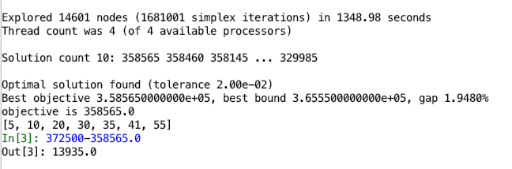

Trial two:

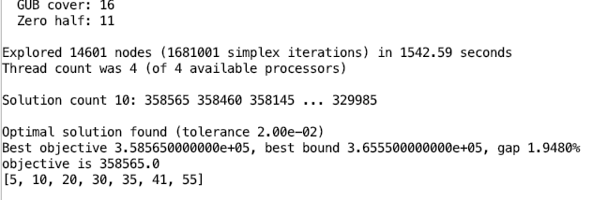

However, the solution has reached 358565 at time=370s. For the rest time, the solver is searching for gap proof.

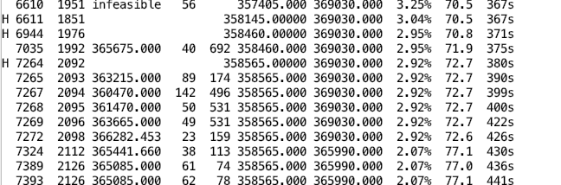

Master Problem

Maximize load pickup, gap=0%

Trial one:

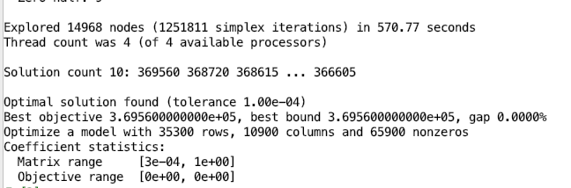

Trial two:

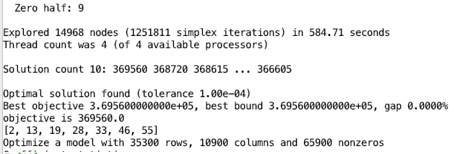

last minute solution obtained

